FORNAX™ ePlanCheck Rule
Rule Information
Rule ID | SWD 9.12.2
Rule Name | Culvert crossing the road requirements
Chapter | 9 Drainage Structures and Facilities
Section | 9.12 Grating over Closed Drain/Culvert
Handbook | Code of Practice on Surface Water Drainage  Addendum No. 1 – June 2013

Rule Description
9.12.2 Where a culvert runs across the road, no sump/grating shall be sited on the road carriageway. Where necessary, sumps with galvanised mild steel grating shall be provided at the two side-tables of the road. In the case of a dual carriageway, a sump with galvanised heavy duty mild steel grating shall be provided at the centre divider.

Rule Interpretation
- This rule checks for sump/grating on the road carriageway.
- No sump/grating shall be sited on the road carriageway. In case necessary, sump with galvanized mild steel grating shall be provided at the two side-tables of road (Figure 01).
- In case of dual carriageway, sump with galvanised heavy duty mild steel grating shall be provided at the centre divider (Figure 02).

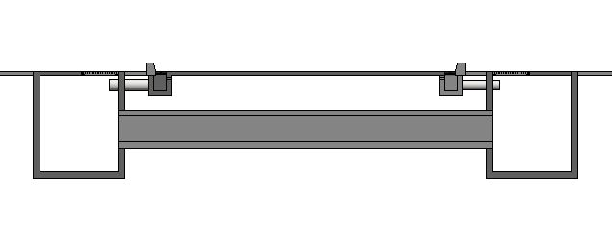
FIGURE 02

Culvert crossing the road, single and dual carriageway
requirements
SECTION

SUMP

CARRIAGEWAY
CLEAR WIDTH

ROAD LEVEL

SUMP

GRATING

GRATING

GRATING

CARRIAGEWAY
CLEAR WIDTH

SUMP

CARRIAGEWAY
CLEAR WIDTH

SECTION

FIGURE 01

SUMP

GRATING

GRATING

GRATING

SUMP

ROAD LEVEL

CULVERT

CULVERT

CULVERT

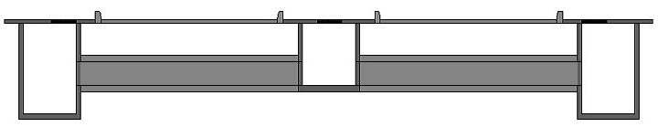

Rule Scenario

Scenario 01 – Compliant
Requirement | Culvert run across the road requirements  - Sumps with galvanised mild steel grating shall be provided at the two side-table of the road.
Description | Sumps with galvanised mild steel grating is provided at the two side-tables of the road
CARRIAGEWAY
CLEAR WIDTH

GRATING

GRATING

GRATING

SUMP

CULVERT

SUMP

ROAD LEVEL

SECTION
FIGURE SCENARIO

Scenario 02 – Compliant
Requirement | Culvert run across the road requirements  - Requirements In the case of a dual carriageway, Sump with galvanised heavy duty mild steel grating provided at the centre divider.
Description | Sump with galvanised heavy duty mild steel grating is provided at the centre divider
CARRIAGEWAY
CLEAR WIDTH

ROAD LEVEL

SUMP

GRATING

GRATING

GRATING

CARRIAGEWAY
CLEAR WIDTH

SUMP

SUMP

SECTION
FIGURE SCENARIO
CULVERT

CULVERT

Scenario 01 – Non-Compliant
Requirement | Culvert run across the road requirements  - Requirements sumps with galvanised mild steel grating shall be provided at the two side-tables of the road
Description | Galvanised mild steel grating is not provided at the two side-tables of the road
SUMP

CARRIAGEWAY
CLEAR WIDTH

SUMP

ROAD LEVEL

SECTION
FIGURE SCENARIO
GRATING

GRATING

NO GRATING

CULVERT

NO GRATING

SUMP

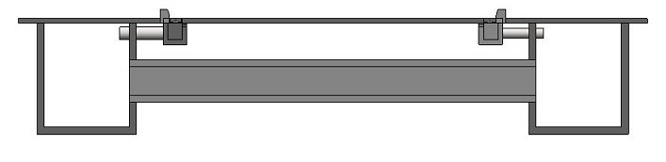

Scenario 02 – Non-Compliant
Requirement | Culvert run across the road requirements  - Requirements sump with galvanised heavy duty mild steel grating shall be provided at the centre divider.
Description | Sump with galvanised heavy duty mild steel grating is not provided at the centre divider.
SUMP

SUMP

CARRIAGEWAY
CLEAR WIDTH

CARRIAGEWAY
CLEAR WIDTH

GRATING

GRATING

SECTION
FIGURE SCENARIO
NO GRATING

ROAD LEVEL

CULVERT

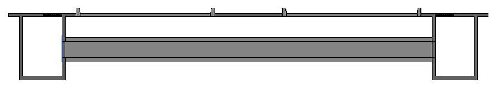

Request For Information

Model PreCheck

Required Elements | Required Attributes
PipeSegment | Name contains “Culvert”
PipeSegment | Name contains “Grating ”
FlowTerminal | Name contains “Sump”
BuildingElementProxy | Name contains “Road ”

Rule Parameters

Element Type 1
State | Type | Property | Operator | Value
Include | PipeSegment | Name | Contains | Culvert

Element Type 2
State | Type | Property | Operator | Value
Include | PipeSegment | Name | Contains | Grating
Include | FlowTerminal | Name | Contains | Sump

Element Type 3
State | Type | Property | Operator | Value
Include | BuildingElementProxy | Name | Contains | Road

Element Type 1 Condition
Element 1 below Element 3, check for presence of Element 2 on both ends.

Result Messages
- 9.12.2 Culvert crossing the road requirements
  - Non-compliant (TotalResultNumeric)
    - BuildingStorey (TotalResultPerFloorNumeric)
    - ElementType1 (TotalResultNumeric=1)
    - ElementType2 is not provided.
    - BuildingStorey (TotalResultPerFloorNumeric)
    - ElementType1 (TotalResultNumeric=1)
    - ElementType2 is not provided.
    - (TotalResultNumeric) ElementType2 not provided
  - Compliant (TotalResultNumeric)
    - BuildingStorey (TotalResultPerFloorNumeric)
    - ElementType1 (TotalResultNumeric=1)
    - ElementType2 is provided.
    - BuildingStorey (TotalResultPerFloorNumeric)
    - ElementType1 (TotalResultNumeric=1)
    - ElementType2 is provided.
    - (TotalResultNumeric) ElementType2 provided
  - Attention (TotalResultNumeric)
    - BuildingStorey (TotalResultPerFloorNumeric)
      - No ElementType1 found.

Sample Result Messages
- 9.12.2 Culvert crossing the road requirements
  - Non-compliant (2)
    - Level 1
    - Galvanised mild steel grating is not provided at the two side-tables of the road.
    - Level 1
    - Sump with galvanised heavy duty mild steel grating is not provided at the centre divider.
  - Compliant (2)
    - Level 1
- Sump and Grating is provided at the two side-tables of the road.
    - Level 1
- Sump with galvanised heavy duty mild steel grating is provided at the centre divider.
- Attention (1)
- Level 1
- No Element found.

Sample Result Model Views
- 9.12.2 Culvert crossing the road requirements
  - Non-Compliant
    - Section View
    - Highlight checked element type 1 in Red.
- Element type 2 is displayed and highlighted in Red
    - All other elements are translucent except element type 1

  - Compliant
    - Section View
    - Highlight checked element type 1 in Green.
- Element type 2 is displayed and highlighted in Green.
    - All other elements are translucent except element type 1 and element type 2.

  - Attention
    - Section View
    - Highlight space in red.

Modelling Guideline
- Specify Name containing “Culvert” for relevant PipeSegment.
- Specify Name containing “Grating” for relevant PipeSegment.
- Specify Name containing “Sump” for relevant FlowTerminal.
- Specify Name containing “Road” for relevant BuildingElementProxy.

Testing Scenario Notes
- Scenario 01 – Non-Compliant
  - Sump and Grating is not provided at the two side-tables of the road.
  - Sump with galvanised heavy duty mild steel grating is not provided at the centre divider.
- Scenario 01 – Compliant
  - Sump and Grating is provided at the two side-tables of the road.
  - Sump with galvanised heavy duty mild steel grating is provided at the centre divider.

Model:
SWD 9.12.2 Scenario 01 Compliant
SWD 9.12.2 Scenario 02 Compliant
SWD 9.12.2 Scenario 01 Non-Compliant
SWD 9.12.2 Scenario 02 Non-Compliant

Link: \\revit02\SG E-Plan Checking\01-WIP\PUB\RuleSpecification_RegRule\PART B\SWD 9.12.2\001\Model\Revit\UAT

Specification Log
RA | Rannear Veluz
Last edit date | 9 November 2018
ePC version
Updates | - V1

